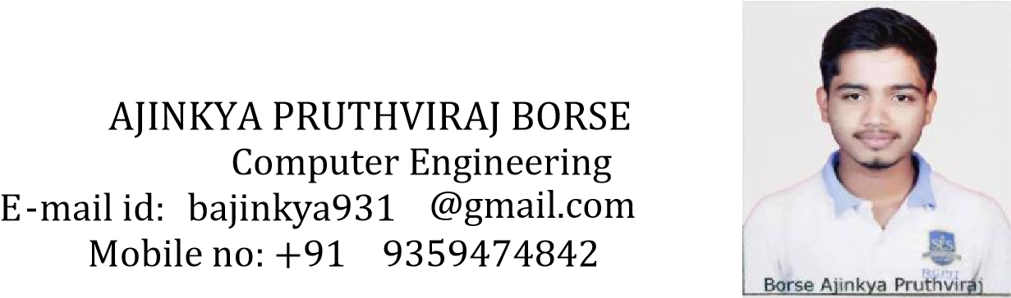

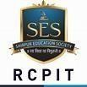

CAREER OBJECTIVE



“To pursue a challenging career and be a part of a progressive organization that gives a scope to enhance my knowledge and utilize my skills towards the growth of the organization”.



EDUCATIONAL DETAILS



* **Bachelor Of Technology in Computer Engineering**

R. C. Patel Institute of Technology,

Shirpur – 202

* **12 (H. S. C) Science from New English School & Jr. Collage,**

Sakri – 2018

* **10 (S. S. C) from New English School & Jr. Collage,**

Sakri – 2016



TECHNICAL SKILLS



* **Programming Languages:**

Core Java, C & C­­++, SQL, Python, HTML & CSS (Basic)

* **Application Software:**

Eclipse, Oracle & Turbo C++



PROJECT



* **DYNAMIC CHURN PREDICTION USING ML ALGORITHM - 2022**



WORKSHOPS



* Participated in online workshops held at RCPIT.
* Organize monthly events to increase the participation of the students in different Social Events.



EXTRA



CURRICULAR ACTIVITY



* Participated in Technical Quiz held at RCPIT.
* Participated in Social Events.



INTERNSHIP



* Internship at M/s. GALAXY COMPUTERS, Sakri in (2018).
* Internship held at RCPIT in (2019)



PERSONAL DETAILS



* Name: Ajinkya Pruthviraj Borse.
* Address: At Post Kawathe, Tal. Sakri Dist. Dhule
* Date of Birth: 25-01-2001
* Gender: Male
* Mobile no.: (+91)9359474842
* E-mail id: bajinkya931@gmail.com
* Languages Known: English, Marathi, and Hindi.
* Interests and Hobby: Watching Movies, Swimming



DECLARATION



I declare that the above information and facts stated are true, correct, and complete to the best of my knowledge and belief.

Date:

Place:



(Ajinkya Pruthviraj Borse)